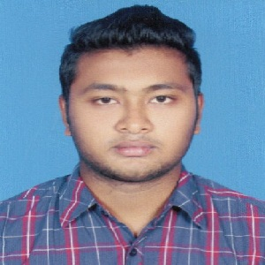
CURRICULUM VITAE
OF
Rahat Hossain Niloy
Cell Phone: +8801677151288.
e-mail: rahathossain1414@gmail.com
Mailing Address: 84/24-Kha, North Vashantek,
Dhaka Cantt., Dhaka-1206.

OBJECTIVE

To prove myself as a quick learner and highly energetic person to face any challenge in such an organization. Also wants to apply my talents, knowledge and courage in Research and Development to create some authentic and novel technologies that meets the cutting edge technological demand of the modern world.

EDUCATIONAL QUALIFICATION

Hon's in Marketing

Institute : Govt. Titumir College, Dhaka
Group/Sub : Marketing
Board : Under Dhaka University
Year : 2nd Year Running

Higher Secondary Certificate (H.S.C)

Institute : B.A.F Shaheen College, Dhaka.
Group : B. Studies
Board : Dhaka
Passing Year : 2017
Result : GPA- 4.42

Secondary School Certificate (S.S.C)

Institute : Bhashantek High School.
Group : B. Studies
Board : Dhaka
Passing Year : 2015
Result : GPA-4.39

LANGUAGE SKILLS

Language | Reading | Writing | Speaking
Bengali | Excellent | Excellent | Excellent
English | Excellent | Excellent | Better

Experience

- Working at Supernova Tecno Ltd as a Call Center Executive (Running).
- Worked at Genex Infosys Ltd as a CSA for 10 Months.

Computer Skills

- Ms Word, Ms Excel, Power point & Internet Email.

PERSONAL DETAILS
Name : Rahat Hossain Niloy
Father’s Name : Md. Jamshed Molla
Mother’s Name : Sajada Parvin
Permanent Address : 84/24-Kha, North Vashantek,
Dhaka Cantt., Dhaka-1206.
Citizenship : Bangladeshi (By birth)
Religion : Islam
Date of Birth : 08th May, 1999.
Sex : Male
Marital Status : Unmarried
Blood Group : O Positive (O⁺)

Specialty

- Communication & Friendly.
- Ready to work with a stress worthy environment.
- Ability to manage things & work with group.
- Good Communication skill.

DECLARATION

I am swearing of such way that all the above information and included documents are correct and true. If any of these wrong and false, I abide by any order and punishment by authority.

DATE:-
………...………….…..
Rahat Hossain Niloy

